WEEK 0 B

A1.

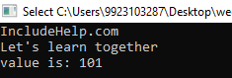

A2.

#include <iostream>

using namespace std;

void naturalsum(int a,int b)

{

cout<<a+b<<endl;

}

int main()

{

class complexa

{

public:

int a,b;

complexa operator +(complexa obj1)

{

complexa temp;

temp.a=a+obj1.a;

temp.b=b+obj1.b;

return temp;

}

};

class matric

{

public:

int a,b,c,d;

matric operator +(matric obj1)

{

matric temp;

temp.a=a+obj1.a;

temp.b=b+obj1.b;

temp.c=c+obj1.c;

temp.d=d+obj1.d;

return temp;

}

};

int a;

do

{

cout<<"Enter 1 for natural sum\nEnter 2 for complex sum\nEnter 3 for matric sum"<<endl;

cin>>a;

if(a==1)

{

int x,y;

cin>>x>>y;

naturalsum(x,y);

}

if(a==2)

{

complexa o1,o2;

cin>>o1.a>>o1.b;

cin>>o2.a>>o2.b;

complexa obj3;

obj3=o1+o2;

cout<<obj3.a<<" + "<<obj3.b<<"i"<<endl;

}

if(a==3)

{

matric o1,o2;

cin>>o1.a>>o1.b>>o1.c>>o1.d;

cin>>o2.a>>o2.b>>o2.c>>o2.d;

matric obj3;

obj3=o1+o2;

cout<<obj3.a<<obj3.b<<endl;

cout<<obj3.c<<obj3.d<<endl;

}

}while(a==4);

}

OUTPUT:

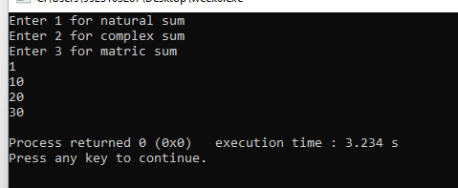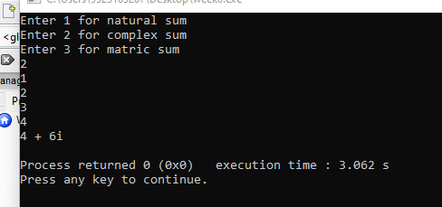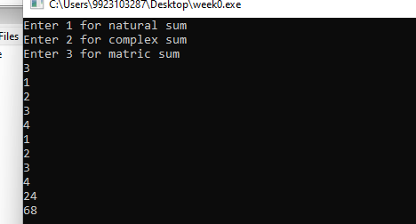

A3.

#include <iostream>

using namespace std;

int main()

{

class vendor

{

public:

string name;

int Lan;

int key;

int mouse;

void input()

{

cin>>name>>Lan>>key>>mouse;

}

void output()

{

cout<<name<<endl<<"Quantity of Lan "<<Lan<<endl<<"Cost of keyboard "<<key<<endl<<"Cost of mouse "<<mouse<<endl;

}

vendor operator >(vendor v1)

{

if(key>v1.key)

{

cout<<v1.name<<" has lower value "<<v1.key<<endl;

}

else

{

cout<<name<<" has lower value "<<key<<endl;

}

}

};

vendor a[10];

for(int i=0;i<10;i++)

{

a[i].input();

}

for(int i=0;i<10;i++)

{

a[i].output();

}

int b,c;

cout<<"Enter the vendor numbers to compare"<<endl;

cin>>b>>c;

a[b-1]>a[c-1];

int maxi=a[0].Lan;

int mini=a[0].key;

for(int i=0;i<10;i++)

{

if(maxi<a[i].Lan)

{

maxi=a[i].Lan;

}

if(mini>a[i].key)

{

maxi=a[i].key;

}

}

cout<<"Max value of Lan is "<<maxi<<endl;

cout<<"Min value of key is "<<mini<<endl;

}

OUTPUT:

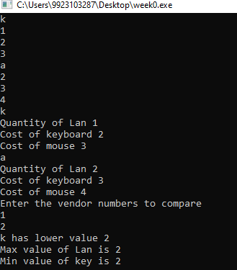

A4.

a.

error as x is private

b.

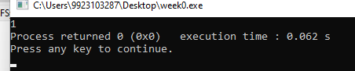

c.

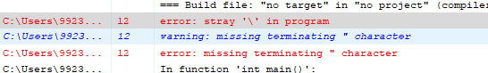

d.

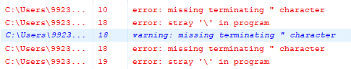

e.

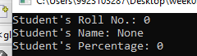

f.

